[Replace Text Here with Your Title]
[List authors by first name (optional middle initial or middle name) followed by last name. Separate multiple authors by commas. Use superscript numbers to link authors to specific affiliations, and symbols for author notes.]
First Middle Last^{1*}, First Last^{2†}, and First M. Last¹
Affiliations:
¹Department Name, University/ Institution
²Precede each affiliation by a superscript number corresponding to the author list.
*Correspondence to: Include the postal mail and email addresses of the corresponding author(s).
†Use symbols to indicate additional author notes (for example, equal author contributions, current addresses, etc.). Use in the following order (†, ‡, §).

Type of Manuscript: CourseSource Teaching Tools and Strategies Manuscript
Funding and Conflict of Interest: [Sources of outside support for the creation of the resource must be named in the contributed manuscript. Please indicate funding that relates to a potential conflict of interest. Conflict of interest exists when an author has financial, personal, or professional relationships that could inappropriately bias or compromise their actions. If no authors have conflicts of interest related to this manuscript, please indicate: “None of the authors have a financial, personal, or professional conflict of interest related to this work.”]
Copyright: © 2024 Author and Author. This is an open-access article distributed under the terms of the Creative Commons Attribution-NonCommercial-ShareAlike 4.0 International License, which permits unrestricted non-commercial use, distribution, and reproduction in any medium, provided the original author and source are credited.
[To affirm that the authors either own the copyright to or have received written permission to use the text, figures, tables, artwork, abstract, summaries, and supporting materials, replace ‘Author’ with the author last name(s). If applicable, submit any documentation regarding permission granted to use copyrighted materials.]
Title and Description of Primary Image: [Provide a title and a short description to accompany your primary image. All submissions must include an image that represents the information in the article (e.g., a picture of a dividing cell for a lesson about mitosis; a picture of a swinging pendulum for a physics lab). This image will be displayed with the title of your article on the CourseSource website (it will not be in the PDF). Ensure that this image is not copyrighted. If students are photographed, students must consent to having their image published.]
Please provide a 4 x 3 image at high resolution (e.g., 800 pixels wide x 600 pixels high).

Abstract
[The abstract should be a single paragraph of 250 words or less. Start with an opening sentence that sets the teaching challenge that you address in this manuscript, provide background information, and briefly describe your take-home message.]

[MAIN TEXT - YOUR FIRST SECTION TITLE]
[Describe how to use the resource, tool, or approach in as brief and practical way as possible, citing references and related materials.

Subheadings can be included within any of the sections to increase readability and clarity. Use the embedded styles in Microsoft Word, accessible from the HOME tab:

Heading 2

Heading 3

Heading 4

Heading 5
Please use the BlockQuote style when you want to:
Designate a student quote, label instructor script during an activity, or differentiae spoken word from the main text.
Please use the StandOut style when you want to:
Make specific text distinct or separated from the main text such as a clicker question. This is similar to BlockQuote in appearance, but should not be used to indicate speech.

*For website links:
- If you want to direct readers to watch a YouTube video, read an article on a website, provide a website for purchasing equipment, etc.:
  - Provide the URL link in parentheses following the underlined text you want hyperlinked.
  - An example: Students watch a short video about photosynthesis (https://www.youtube.com/watch?v=2KZb2_vcNTg) prior to the activity.
  - Do not include in the citation list.
- If you want to use an article from a website as a citation (e.g., NPR), please use it as you would a normal citation. See the References section below to see how to format a Website citation.
The actual URL in parentheses will be removed prior to publication, but is necessary for you to include to ensure we publish using the correct links.]

Important information about participant data:
Institutional Review Board (IRB)/ Behavioural Research Ethics Board (BREB) Approval
- You may be required to provide an ethics board protocol number. US Federal regulations require IRB review and approval for projects that:
  - (1) Meet the definition of research
  - AND (2) Involve human subjects
- Research is defined as “a systematic investigation, including research development, testing and evaluation, designed to develop or contribute to generalizable knowledge.” (e.g., testing a hypothesis; randomization of subjects; comparison of case vs. control)
- A human subject is defined as “a living individual about whom an investigator (whether professional or student) conducting research:
  - Obtains information or biospecimens through intervention or interaction with the individual, and uses, studies, or analyzes the information or biospecimens; or
  - Obtains, uses, studies, analyzes, or generates identifiable private information or identifiable biospecimens."
- Most articles submitted to CourseSource will be considered as Quality Improvement and/or Program Evaluation, and IRB review is not required because the project does not constitute research as defined under 45 CFR46.102(d).
- However, if your project is considered research and/or you present and discuss human subjects’ data, IRB review is required. This includes, but not limited to:
  - Student performance data (e.g., pre/post scores on an assessment)
  - Student quotes, particularly if the quotes were gathered from a survey that collected identifying information (e.g., their name) or from interviews
- If you use student data, you must either provide an IRB protocol number OR certification by the IRB or the institution that IRB review was not required. Please provide this information in the Lesson Plan or adjacent to the data (often in the Teaching Discussion section).
  - IMPORTANT: While your project may not be considered ‘research on human subjects’, intent to publish results may change its designation to research and thus require IRB approval. Ensure that when submitting for approval to your IRB that you state your intent to publish results from the project (e.g., survey data, test scores, quotes).
  - If considered research on human subjects, it will likely undergo review under the “exempt” category. This means that your study requires only an initial review and is exempt from ongoing review. Exempt does not mean exempt from any IRB review nor exempt from general requirements for informed consent and protection of subjects.
- What if my institution does not have an IRB board?
  - We recommend that you do not provide any human subjects’ data. Instead, discuss your observations, overall student reactions, or general classroom performance.
  - If you still wish to provide such data, you must provide a statement(s) in your article regarding:
    - IRB review was not available
    - Description of ethical procedures and practices that were followed (e.g., maintaining the anonymity of student participants, data management and protection, and student consent)
    - The research posed minimal risk to students and was conducted in established or commonly accepted educational settings
- Common exceptions:
  - An IRB is not needed if you are presenting data collected from an anonymous survey. If the survey collected identifying information (such as names or demographics), even if de-identified later, we cannot publish the data without an IRB.]

Supporting Materials
- S1. Writing Hypotheses – Student Handout
- S2. Writing Hypotheses – Slides
- S3. Writing Hypotheses – Quiz [Instructor view only]
[Replace the above text with a bulleted list of all your supporting files. A short description is not required, but can be added if desired. If you would like to restrict access of any supporting files to only instructors (e.g., exam questions, exam key), please indicate in the bulleted list.]
Use the following nomenclature to list your materials. Begin with the letter “S” and the number representing the order in which the material is referenced in the article (S1, S2, S3…). Follow with a short version of your article title. For example, shorten “Using Hypothesis Writing and Testing to Develop Skills in Scientific Inquiry,” to “Writing Hypotheses”. Then include a brief title of the resource, such as lecture slides, worksheet, etc.
When referencing supporting files within the text, do not refer to these files as “supplemental.” You may refer to the supporting files using parentheses or within the text. If using parentheses, please list the numbers the same as you would an ASM citation. For example: (Supporting Files S7, S8) and (Supporting Files S10–S15). If referencing file(s) within the text, please use proper grammar.
Examples of in-text supporting file reference in parentheses:
- ONE: Print one set of cards for the sorting game (Supporting File S1).
- MULTIPLE: Additional learning materials (Supporting Files S1, S4–S15) were created to facilitate the online transition as a result of the COVID-19 pandemic.
Examples of in-text supporting file reference outside parentheses:
- ONE: If this dataset will be used for the activity, instructors may refer to information presented in Supporting File S14.
- MULTIPLE: Example grading rubrics are in Supporting Files S12 and S13.
All Supporting Materials MUST be referenced at least once in the main text.
Important information:
- We request authors limit the number of supporting files to 20 at most.
- When naming the actual supporting files, use the exact same titles as named in the Supporting Materials bulleted list. For example, “S2. Writing Hypotheses – Slides.pptx”
- When possible, please use editable file formats such as Word, PowerPoint, Excel, etc. Avoid PDFs if possible – PDFs are difficult to be made accessible as well as hard for reviewers, editors, and readers to edit.
- Wherever possible, ensure that the article title and name(s) of author(s) are visible when a reader opens the file. Suggested areas include in a header, on the first page/first slide, or as a “Notes” sheet in a spreadsheet workbook.
- Upload a separate file for each supporting material item when you submit your article. Do not embed any of this information in the manuscript text file.
- The maximum size for each supporting file is 100 MB.
- In supporting files that contain lecture slides, it is helpful to include notes about materials and transitions to help the reader teach the materials.

Images and Copyrighted Materials
Do NOT include copyrighted materials in your manuscript or in your Supporting Materials.
All images have to either be open source, the author’s own creation, or have received permission from the original creator. Figures from papers or textbooks are not allowed (unless authorized in writing).
To ensure there are no copyrighted materials, authors must provide an adequate description of where images or photos are sourced from. For example:
- Image credit: author name, picture taken in-house
- Image of Earth on left side is open source from https://www.website.com
- Figure reprinted with permission from journal (article citation)
Authors should provide this information in the image caption. If in PowerPoint, please put the information in the Slide Notes for each slide that contains an image.
If the image is copyrighted, it must be deleted. Authors can choose to replace the image with an open source version (with reference as described above). Or they can put a placeholder box with a description of what image to insert. For example:
- Insert Figure 8 from Flowers et al., 2023 here (provide link, DOI, or citation)
- Place image of particle accelerator from this website (embed link) here
This way, there is no uncertainty about the image’s open source/ copyright status and it still allows readers to use images recommended by the authors.

How to Find Open Source Images
Below are suggested methods for finding open source images. Please only submit images that are in the public domain or are compatible with our licensing, CC BY-NC-SA 4.0 (Creative Commons Attribution-NonCommercial-ShareAlike 4.0 International License), such as: BY, BY-NC, and BY-NC-SA.
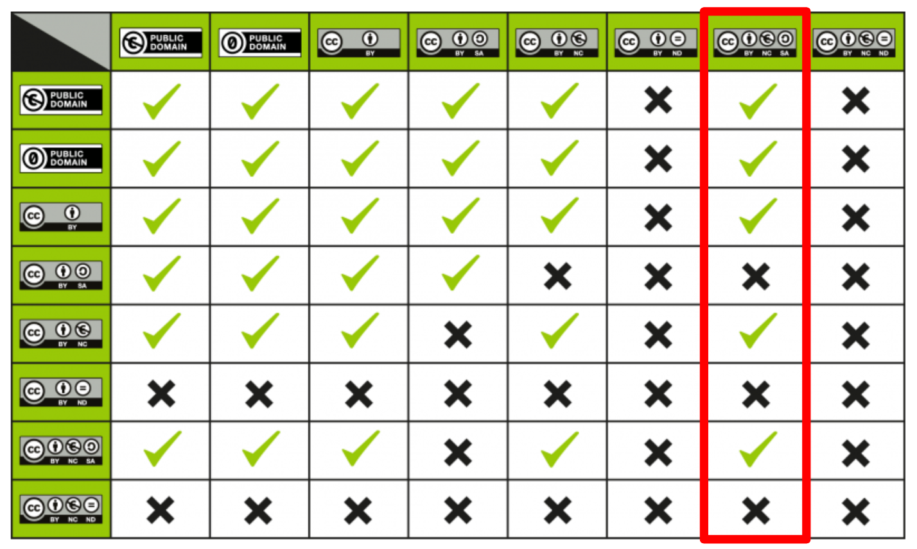
Image modified from https://pressbooks.oer.hawaii.edu/oertraining2018/chapter/cc-license-compatibility/

Creative Commons Search
This site links out to a variety of search engines for various media. Try them out yourself! Simply go to Creative Commons Search, select your search engine, and submit your inquiry. Here’s how you can refine your search or check that your searched images are compatible:

Openverse
Ensure “Filters” is open on the right side, and select compatible licenses.

Flickr
Click on an image of interest. On the loaded page, scroll underneath the photo and click on “Some rights reserved” on the right side to view the license.

Google Images
Refine your search by selecting “Tools” > “Usage Rights” > “Creative Commons licenses.” When you click on an image, you will find “License details” hyperlinked below. Click on the link to make sure the image is compatible.

Wikimedia Commons
Click on an image file of interest. On the loaded page, scroll down to “Permission” or “Licensing.”
However, it is easier to do the following: On the right hand side of the search results page, click “Switch to MediaSearch.” Once the page is loaded, select “License” > “No restrictions.”

Acknowledgments
[Replace these instructions with your acknowledgements, which can include funding information.]

Table and Figure Captions
[Upload a separate file for each figure and table when you submit your article. Do not embed any of this information in this text file. All Tables and Figures MUST be referenced at least once in the main text.]

Tables
Table 1. Name of table. Table captions should contain a short description of the table.

Figures
Figure 1. Name of figure. The figure caption should begin with a sentence that describes the overall “take home message” of the figure. (A) Indicate figure parts with capital letters. (B) You should also reference/ describe each figure part in the main text as well.

IMPORTANT:
- All tables must be submitted using the provided table template and as a DOCX file (not PDF).
- All figures must be submitted in a graphic file format such as JPEG (PDFs will not be accepted).
- Ensure that no copyrighted materials (or copyrighted materials without permission) are included in your article or in your tables and figures.]

References
[Replace these instructions with your reference list.]
The citation style of CourseSource follows the standards set by the American Society for Microbiology (ASM). Here are general guidelines:
- Cite references in the text by placing the reference number in parentheses (or brackets when relevant). Number the references in the order in which they appear. For example:
  - Several CUREs have been developed recently in the field of ecology (1-5). CURES have the potential to increase student success (6, 7). There are multiple consortiums available to help scholars develop their own CURES (see Consortium A [8], Consortium B [9], and Consortium C [10] for more information). Despite this growth, research suggests that interdisciplinary CUREs are lacking in the current literature (4).
- If you are using reference organization software, you must submit an unlinked version.
- Abbreviate the names of journals, according to the list in NCBI. Remove any periods.
- List all authors of the reference.
- Use sentence case for titles (helpful website: https://titlecaseconverter.com/ )
- DOI numbers must be included, if a citation has one. Format for DOI numbers can be:
  - doi:10.1187/05-06-0082
  - OR
  - https://doi.org/10.1187/05-06-0082
- If multiple references are cited in the same citation, number them by date order with the oldest citation as the lowest number.
- References in the list should only be of references in the main text. Any references in the Supporting Materials should be listed separately within the Supporting Material.
Examples of reference style:
Journal Articles
- Knight JK, Wood WB. 2005. Teaching more by lecturing less. Cell Biol Educ 4:298–310. doi:10.1187/05-06-0082.
Book/ Report
- Handelsman J, Miller S, Pfund C. 2006. Scientific teaching. W.H. Freeman, New York, NY.
Book Chapters
- Dennen VP, Burner KJ. 2008. The cognitive apprenticeship model in educational practice, p 425–439. In Spector JM, Merrill MD, van Merriënboer J, Driscoll MP (ed), Handbook of research on educational communications and technology, 3rd ed. Lawrence Erlbaum Associates, New York, NY.
Websites
Author (if unavailable, use website host). Year published (if unavailable, use update/revision date; if unavailable, write “n.d.”). Article title. Website host (if not already used as author). Retrieved from URL (accessed day month year).
Examples:
- California Department of Fish and Wildlife. 2022. Gray wolf. Retrieved from https://wildlife.ca.gov/Conservation/Mammals/Gray-Wolf (accessed 19 October 2022).
- Ray J, Marken S. 2014. Life in college matters for life after college. Gallup. Retrieved from https://news.gallup.com/poll/168848/life-college-matters-life-college.aspx (accessed 14 July 2022).
Please note an important distinction! If you use a website page as a citation, please cite it properly—such as (4)—and include the citation in your references list. If you are providing information for readers (such as a YouTube video for students to watch, a website to buy lab supplies from, a popular science article for students to read, etc.), do not cite the website in-text and do not include it in the references list. Formatting would look as follows (as described previously):
Students watch a short video about photosynthesis (https://www.youtube.com/watch?v=2KZb2_vcNTg) prior to the activity.
Visit the ASM website for the most current information regarding formatting of references. This website is also a helpful resource for how to cite different kinds of references, but may not have the most up-to-date information.
Citation Managers
Two citation styles are available to download from the CourseSource For Authors page. For information on how to install and the difference between the two versions, please visit our website.

