Investigating Changes in Species’ Ranges Over Time  Using Digitized Natural History Collections:  Potential Correlation with Global Temperature Change | 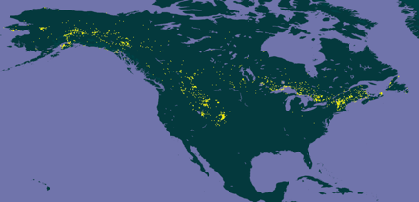

Objectives

Students completing this module will be able to:
- Predict how global temperature patterns might influence species’ distributions.
- Use quantitative reasoning to collect, clean, and analyze data from a large, curated, aggregated dataset.

Introduction

With global average temperatures rising since the 1940s (Figure 1), populations of species may no longer be able to successfully occupy the same geographic range as they once had. There is strong evidence that rising temperatures has already led to significant shifts in species’ distributions. In this module, you will review published research data describing this evidence and the predicted consequences of biodiversity redistribution. You will then investigate the distribution over time for a species of your choosing using data available from digitized Natural History Collections.

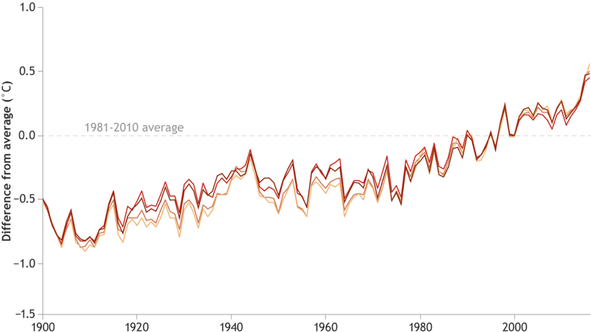

Figure 1. Temperature anomalies (deviations from average) over time.

Activity 1:

Procedure

- Read the article provided. This is a metanalysis co-authored by 41 biodiversity scientists.
  - Pecl, GT. et al. 2017. Biodiversity redistribution under climate change: Impacts on ecosystems and human well-being. Science 355, eaai9214.

- Answer the questions below.

Biological Responses and Ecosystem Health

    - Based on the metanalysis performed, how far, on average, have terrestrial taxa moved poleward per decade? How far for marine taxa?

    - How have the ranges of terrestrial organisms living on mountainsides and fish in the oceans changed as a result of warming?

    - How can changes in species’ distributions lead to changes in biotic interactions?

    - Give an example of how biodiversity redistribution can impact human well-being.

Activity 2: Investigate a Species

Procedure

- Identify a species you are interested in investigating. Each member of your team should investigate a different species, but work together and compare your progress as you complete each step of the procedure. What species will you be investigating?
Species could be assigned to students to ensure coverage of different taxonomic groups or to investigate specific taxa of broad or local interest.

- For the species you select, do some web research about its habitat and life history. Briefly summarize this information below.

- Make a prediction. Do you think that the range of this species has shifted over the last century? What features of your species’ biology lead you to make this prediction.

Activity 3: Generate Distribution Maps

You will be using the GBIF biodiversity data portal. The Global Biodiversity Information Facility includes both specimen-based and observation-based natural history collection data. We will be using GBIF records to estimate species ranges and range changes over time.

Please note that the absence of a species record from a specific place at a specific time cannot be considered proof that it wasn’t present in that location in that year, so this is only an estimate of species ranges that we can use to generate hypotheses. However, since we cannot go back in time and carry out a systematic sampling protocol, for some species these are the only data available to make these range change estimates.

Also note that while we are looking for possible range shifts correlated with increased global temperatures, there are other factors that might lead to changes in species’ ranges over time. What might some of these factors be?

Procedure

- Navigate to the GBIF website @ https://www.gbif.org

- Create a user account if you don’t already have one.

- Click on “Species” above the search box.

- Enter the name of your species in the search box. Watch out for autocorrect!

- Search results will appear to the right. Click on the one that best matches what you are looking for.

- Download the Directly below the map will be a slider for time of collection ranging anywhere between 1600 and the current date.

- Take screen shots of the map in 20-year increments beginning with 1900-1920 and ending with 2000-current year. Note: Some organisms do not have data on specific years, use the closest number to the target data (e.g., 1941 instead of 1940 or 1999 instead of 2000).

- Paste your six maps into the appropriate boxes below.

1900-1920 | 1920-1940
1940-1960 | 1960-1980
1980-2000 | 2000-20XX

Activity 4: Examine Latitude Over Time

Procedure

- Return to your GBIF search results and click on the “Explore” button below the map.

- In the menu section to the left, open the “year” tab and set the range to 1900 – present.

- Select “Download” from the menu above the specimen records, then “CSV” to download your data set.

- Open your dataset in Excel. You will need to import the CSV file to split the data into separate columns.

- Clean your data by removing unnecessary columns. The only essential columns are “Latitude” and “Year”, but consider keeping at least “Longitude” and “Basis of Record” to provide some context for your data.

- Sort by “Year” and remove any rows that do not have the year recorded.

- Remove any obvious outliers.

- Create a scatterplot of latitude vs year (with axes labeled). Copy and paste your graph into the space below.

Activity 5: Interpret Your Data

- What might be some predicted impacts on ecosystems (including humans) if your species did have a change in range over the last century?

- Is there evidence of a latitudinal change in range for your species? Summarize the data.

- What other factors (besides temperature) might influence the range of your species

