Introduction:

The population trend of the bald eagle during the past 70 years provides a history with several important lessons. After World War II, the insecticide, dichlorodiphenyl-trichloroethane (DDT), was allowed for widespread agricultural use. Despite its effectiveness in killing insect pests on crops, the chemical accumulated in the body tissues of bald eagles (through biomagnification), making the birds unhealthy and causing them to lay thin-shelled eggs that broke as soon as the parents sat on them to begin incubation. The numbers of bald eagles in the contiguous United States, which were already declining due to hunting, plummeted as a result. The bald eagle was listed as endangered under the Endangered Species Act of 1973, and this protection, combined with the national ban of DDT in 1972, is credited with leading to the recovery of these magnificent birds.

Bald eagle numbers not only vary over historical time, but they also vary across the landscape with changes in the seasons. Like many birds, most bald eagles migrate in the winter in search of food. The primary food source for bald eagles is fish, and the eagles need open water to access the fish, which in many locations consists of spawning salmon at the shallow edges of lakes and streams. Once the lakes and streams freeze over, the eagles have to use an alternative food source (i.e., carrion such as dead deer or elk) or go elsewhere. Bald eagles will also feed on ducks, although not as frequently as fish. During the migration the eagles follow a route with several stopovers at lakes and streams along a southward corridor. The bald eagles travel individually, and although a given eagle may spend only a week or two at a stopover, collectively the eagles may be present for several months. Although the birds travel as individuals, once at a stopover, they will roost together in the evening (i.e., location were eagles gather to sleep for the night) and perch together in the same or adjacent trees.

Because of its endangered status in the early 1970s, several agencies and biologists initiated long-term surveys. Some of the surveys are ongoing nationwide surveys, such as the Midwinter Bald Eagle Survey, and others are local surveys such as the data set that is the focus of this activity.

Since 1974, just two years after the ban on DDT, the Bureau of Land Management in Northern Idaho has counted migrating bald eagles every winter. The bald eagle counts are taken on a weekly basis at eleven sites around Wolf Lodge Bay on Lake Coeur d’Alene in the Pacific Northwest (Figure 1). The eagles stop at Lake Coeur d’Alene because of the availability of kokanee salmon, which is a land-locked strain of sockeye salmon (Onorhynchus nerka). The salmon live to about three years of age and then spawn in November or December, dying immediately after spawning and leaving a large number of carcasses in the shallow water for the eagles to feed on. The biologists go out by car and count the number of eagles on perch trees or flying at these sites. The adult and immature eagles are counted separately. The sites are usually visited once per week in the morning from mid-November to the beginning of February with the highest numbers of eagles usually being present during December. In addition, the biologists record weather conditions, human activity at each site, salmon abundance, and various other factors that could influence the counts of migrating eagles.
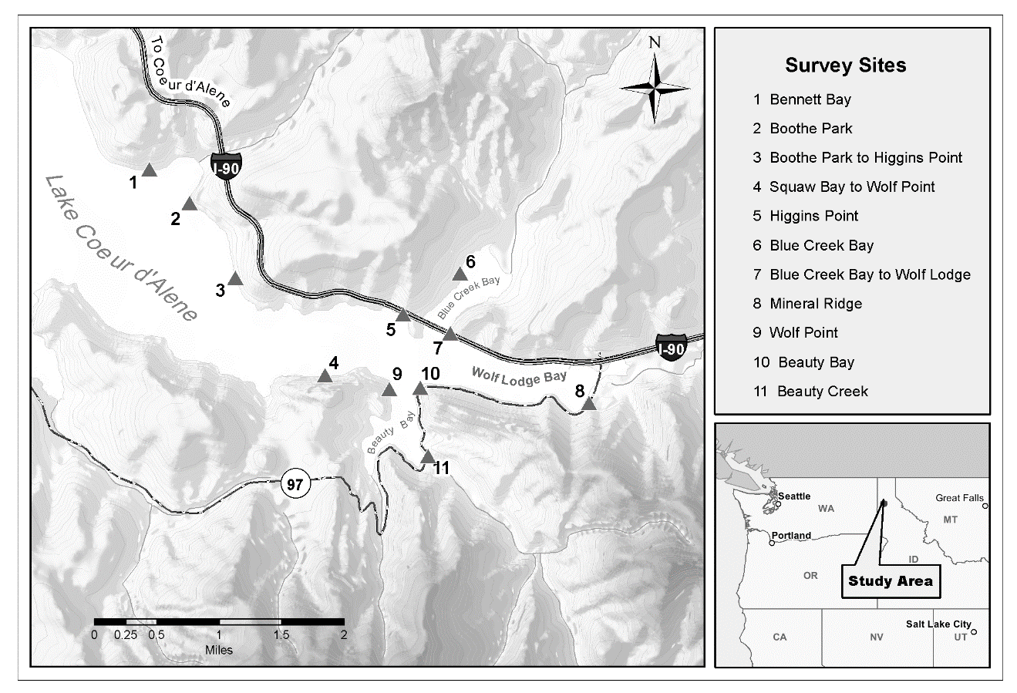
Figure 1: Map of the study area in the Pacific Northwest (United States) and the bald eagle winter survey sites along Lake Coeur d’Alene, Idaho.

Pre-class Assignment

Scientific process | Chosen experiment: List your topic here
Question:

Hypothesis:

Prediction:

Experimental Design

Independent variable(s):

Dependent variable(s):

Type of graph (line or bar):

Type of statistical analysis

