- Data Set Homepage

Title: Have fish assemblages recovered from the legacy of acid rain?

The Ecological Question:
Acid rain has impacted small mountain streams in the Northeastern United States for decades. These small streams represent critical habitat for cold-water fish assemblages, whose habitats are being further constricted by climate change. Given the well-documented reductions in acid deposition since passage of the Clean Air Act, how has water chemistry and fish diversity responded? Past and present data on fish assemblages in National Parks can help answer this question and identify the limiting factor on diversity in mountain streams.

Ecological Content: Diversity, limiting factors, aquatic ecosystems

What Students Do:
Guided Inquiry & Skill Building
Using a nested data set strategy (Kastens et al. 2015), students begin by collecting fish assemblage data using standard backpack electroshocking techniques (Zale et al. 2012) or by identifying fish via snorkeling. If a field trip to a local stream is not possible, images and descriptions of each fish species in the dataset are available on-line at EFISH: The Virtual Aquarium (http://web1.cnre.vt.edu/efish/). Through these activities students gain an understanding of the data, its limitations, and experience a local stream. Students then carry this understanding forward to see if their data fit within predictions intervals of the species richness observed based upon the acid neutralizing capacity of the stream (Figure 3 in the Student Instructions). This gives students experience doing simple linear regression analysis (either in Excel or in R), testing predictions, and comparing their data to an existing model. It also starts small by using data from an intensive study of 13 streams before expanding to an open-ended inquiry of a larger dataset.

Open-Ended Extension
Building upon the knowledge and skills from the previous session, students can begin to explore other relationships within a larger database. In addition to the datasets accompanying this module, students can learn to request and search other publicly available data. For example, the National Park Service has collected long-term monitoring data on fish assemblages and water quality in the northeastern United States (e.g., Shenandoah National Park and Great Smokey Mountain National Park). These Parks have decades of monitoring data, over various spatial and temporal scales of resolution, for water chemistry, fish and aquatic invertebrates.

Larger data sets will allow students to develop and test hypotheses about correlations that go beyond the initial inquiry and skills development in testing the relationship between fish diversity and acid neutralizing capacity. Examples of other original questions that can be address with these data are:
- Are there species-specific responses to stream acidification? (either pH or ANC)
- Is total fish biomass correlated to stream acidification? (we might expect a complex response for this given that Nitrate is an acidifier but all biologically active)
- Has the relationship between acidification and fish diversity changed through time?
- Is there a relationship between acidification and aquatic invertebrate diversity?
The final product is a series of brief oral presentations (~5 minutes) where students evaluate their peers based upon originality of the question, data compilation and analysis, visual and oral interpretation of the results. Students are also evaluated on their participation in asking questions of their peers.

Student-active Approaches: Problem based learning, cooperative learning, reports, pyramid exam

Skills:
- Gain hands-on experience with backpack electroshocking or snorkeling, which are common fisheries techniques.
- Develop personal insight into limiting factors on diversity.
- Demonstrate proficiency in running and interpreting a regression analysis.
- Learn how to search large, publicly available databases.
- Develop and test an original hypothesis.
- Ability to make an evidence-based argument, in the form of an oral presentation.

Assessable Learning Outcomes:
Students will create and interpret graphical displays of data and regression analysis. Students will develop and test original hypotheses, and give a brief peer-reviewed presentation of results. Students will also show proficiency in searching and organizing large publically available datasets.
Data Sources:
Water chemistry data is available at: http://people.virginia.edu/~swas/POST/scripts/overview.php
Additional data on streams in Shenandoah National Park: https://www.nps.gov/shen/learn/nature/inv_water.htm
Long-term monitoring data from Shenandoah National Park: https://pubs.usgs.gov/sir/2013/5157/
Authors: Christine May and Patrick Harmon
Institution: Department of Biology, James Madison University
Acknowledgements: This case study was inspired by the long-term water chemistry data collected by the Shenandoah Watershed Study at the University of Virginia, and collaborations with Shenandoah National Park that were facilitated by a grant from the Shenandoah National Park Trust and additional support from the 4-VA Consortium of Universities.
Relevant Cover Image: Uploaded separately to QUBES submission portal

- Overview
Acid rain has impacted small mountain streams in the Northeastern United States for many decades. These small streams represent critical habitat for cold-water fish assemblages, whose habitats are being further constricted by climate change. Predictive models, assuming a 2˚C rise in stream temperatures due to climate change, suggest that cold water species like eastern Brook trout (Salvelinus fontinalis) will face a ‘habitat squeeze’ as pressures from stream acidification overlap with pressures from rising stream temperatures (McDonnell et al. 2015). Therefore, the viability of mountain streams in providing habitat is critical for preserving diverse native fish assemblages. Amendments to the Clean Air Act implemented in 1995 have greatly reduced atmospheric emissions of acidic compounds; however, the response of streams and their fish assemblages is not well understood. In this module, we ask the question ‘what is the current relationship between stream acidification and fish species richness in Shenandoah National Park?’ In addressing this question, students will explore limiting factors on diversity and develop skills in predictive regression-based modeling. The module contains both a guided inquiry and open-ended explorations.

Environmental Policy
The Clean Air Act of 1970 and an Amendment to the Clean Air Act in 1990 were aimed at reducing sulfur dioxide (SO₂) and nitrogen oxide (NO_{x}) emissions from power plants and motor vehicle, placing a cap on emissions at 8.9 million tons annually, a reduction of 10 million tons when compare to emissions in 1980. Phase 1 of the Amendment was enacted in 1995, placing restrictions on 21 of the largest coal-burning power plants in the eastern and mid-western United States. Phase 2 was implemented in 2000, restricting emissions from smaller coal, gas and oil burning plants. Between 1990 and 2000 sulfur dioxide emission fell from 15.7 million tons to 11.2 million tons and by 2013 emissions had fallen to 3.2 million tons (EPA, 2001; EPA, 2013), resulting in declines in sulfate deposition across the eastern United States and the increased pH of rainwater (Figure 1).
The decrease in acid rain is widely viewed as an environmental success story. But what about streams that became acidic? Nearly 25 years after the Clean Air Act, some waterways in the Northeast have seen recovery while others have not. The difference is in the underlying bedrock and its ability to buffer (in other words neutralize) acid inputs. This is measured in the form of Acid Neutralizing Capacity (ANC), which quantifies the availability of base cations (Ca²⁺, Mg²⁺, K⁺ and Na⁺) that are the result of mineral weathering rates. Weathered base cations dissolve in soil water and move into streams where they can neutralize acidity from anions (NO₃⁻ and SO₄²⁻).

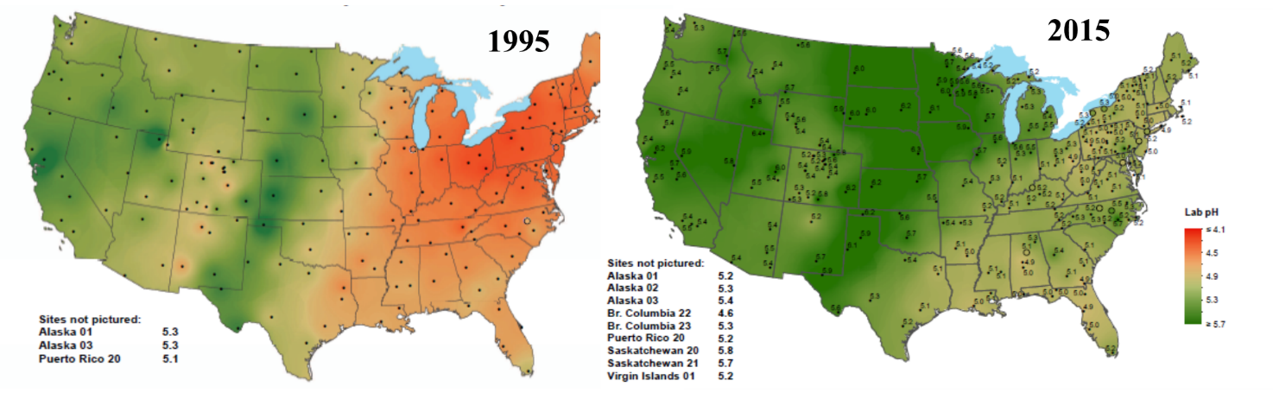
Figure 1. Maps created by the National Atmospheric Deposition Program showing an increase in the pH of rainwater. Data on wet and dry deposition is mapped annual throughout the United States (http://nadp.sws.uiuc.edu/ntn/annualmapsByYear.aspx ).

Environmental Science & Management
The boundaries of National Parks protect many small mountain streams that provide habitat for cold water fish in the United States; however, these boundaries cannot prevent impacts of acid rain or climate change. The deposition of acidifying compounds has resulted in the depletion of acid neutralizing capacity of watershed soils and the acidification of streams. Decades after Amendments to the Clean Air Act, scientists and land managers need evidence to understand whether streams have recovered the impacts of acid rain or if the legacy persists.
Previous research by Bulger et al. (1995) revealed a strong correlation between ANC and fish species richness in 1995, when acid inputs were still high. Recent research by Harmon (2017) indicates that this trend continues despite reductions in atmospheric emissions. Streams draining bedrock types that are acid sensitive (e.g., siliciclastic and granitic rocks that produce few base cations) have seen no recovery in fish diversity; whereas streams draining basaltic bedrock that contains veins of calcite are experiencing an increase in fish diversity (Figure 2).
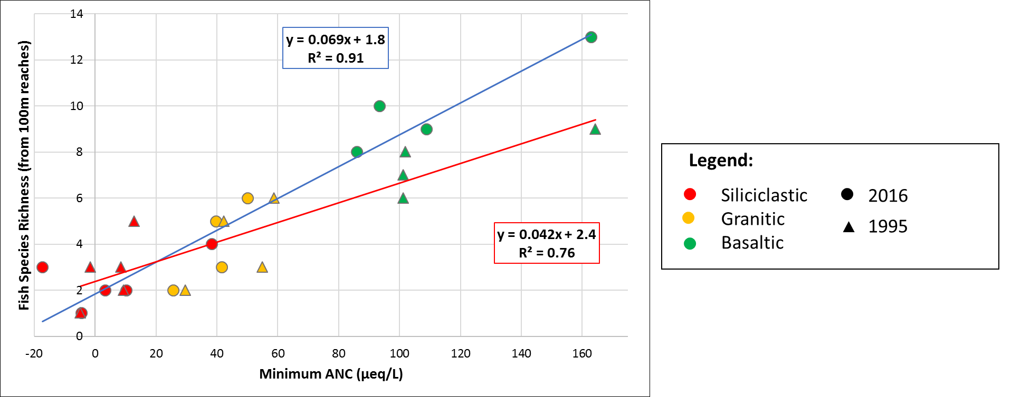
Figure 2. The correlation between Acid Neutralizing Capacity and fish species richness in thirteen streams within Shenandoah National Park. Initial data from Bulger et al. (1995; red regression line) compared to recent data from Harmon (2017) indicates limited recovered from stream acidification (blue regression line).

Limiting Factors
In ecology a limiting factor for a species is typically an environmental condition or resource that limits the growth, abundance, or distribution of an organism or a population in an ecosystem. The concept is based upon Liebig’s Law of the Minimum, which states that growth is controlled not by the total amount of resources available, but by the scarcest resource. Limiting factors may be physical, chemical or biological. Here we hypothesize that the stream fish diversity in Shenandoah National Park is limited by acid neutralizing capacity. The evidence for such a limitation is based upon how strongly of a predictor that ANC is on fish diversity. If acid neutralizing capacity was not limiting, we would expect that it would explain very little in terms of the variation in species richness (e.g., low R-squared value and high p-value). There are also formal ways to conduct a limiting factors analysis, which compares resources and environmental conditions to each other.

- Data Sets
The small, initial exploration dataset is ‘Harmon_SNP_Fish_Diversity_data.xls’.
The larger dataset is ‘Shenandoah_Park_Fish_data.xls’.
The water chemistry data is ‘Shenandoah_Watershed_Study_data.xls’.

- Student Instructions:
Initial Skill Building
A field trip to a local waterway is the best way to gain a deeper understanding of the data and the methods. With the proper permitting and approval, select a stream that has water chemistry data available. At the stream, select a 100m reach to sample the diversity of fish species present. Fish sampling by Harmon (2017) utilized three-pass depletion backpack electroshocking, a common fisheries technique. Alternatively, snorkeling can be an effective and fun way to identify fish. The field trip is designed to give you an understanding in field sampling techniques and the fish diversity data, its limitations, and to experience a local stream. You will then carry this understanding forward to see if your data fit within predictions intervals of the species richness observed based upon the acid neutralizing capacity of the stream (Figure 3; based upon Harmon, 2017).
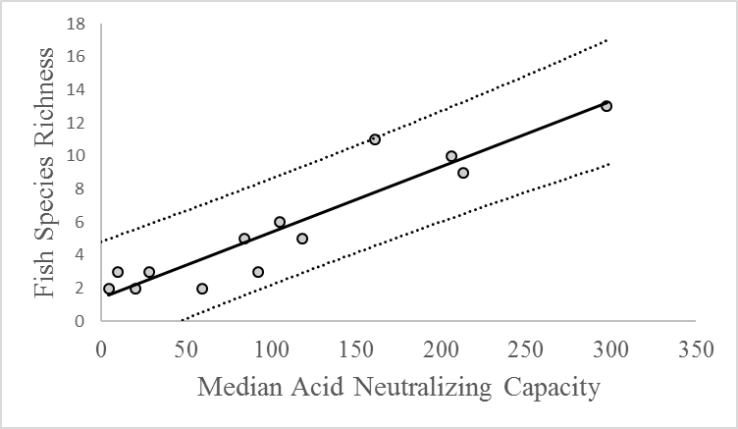
Figure 3. Prediction intervals on the correlation between ANC and fish species richness based on data from 2016 by Harmon (2017).

Guided Inquiry
With assistance from your instructor, re-create the plot of ANC and Fish Species Richness from the thirteen streams investigated by Harmon (2017). This will give you experience doing simple linear regression analysis (either in Excel or in R), testing predictions, and comparing your data to an existing model. Begin by creating a scatterplot, add a trendline, and report the p-value and R-squared value (which represents how close the data fit the predicted line; with larger values representing greater predictive ability of the statistical model). Next add data on the number of species your class observed and the median ANC of your local waterway, as reported in available monitoring data. Does your data support the hypothesis that acid neutralizing capacity is the limiting factor for fish diversity? Based upon what evidence?

Open Ended Inquiry
Next, investigate the larger data set provided with this module or use publically available data from the National Park Service to develop and test a specific hypothesis. Look for correlations that go beyond your initial inquiry of testing the relationship between fish diversity and acid neutralizing capacity. Examples of other original questions that can be address with these data are:
- Are there species-specific responses to stream acidification? (either pH or ANC)
- Is total fish biomass correlated to stream acidification? (we might expect a complex response for this given that Nitrate is an acidifier but all biologically active)
- Has the relationship between acidification and fish diversity changed through time?
- Is there a relationship between acidification and aquatic invertebrate diversity?
The final product is a series of brief oral presentations (~5 minutes) where students evaluate their peers based upon originality of the question, data compilation and analysis, visual and oral interpretation of the results. Students are also evaluated on their participation in asking questions of their peers.

Literature Cited:
Bulger, A., Steg, M., Dennis, T., MacAvoy, S. 1995. Stream chemistry and fish species richness in Shenandoah National Park. Shenandoah National Park: Fish in Sensitive Habitats Project Final Report. V.4:85-101.
Harmon, P., 2017. Revealing the current relationship between stream acidification and fish species richness: What is the status after two decades of recovery? M.S. Thesis, James Madison University, Harrisonburg, VA.
Kastens, K., Krumhansl, R. and Baker, I., 2015. THINKING BIG. The Science Teacher, 82(5), p.25.
McDonnell, T., Sloat, M., Sullivan, T., Dolloff, C., Hessburg, P., Povak, N., Jackson, W., Sams, C. 2015. Downstream warming and headwater acidity may diminish coldwater habitat in southern Appalachian mountain streams. PLoS ONE. 10(8): e0134757.
Zale, A.V., Parrish, D.L. and Sutton, T.M., 2012. Fisheries techniques, American Fisheries Society. Bethesda, Maryland.

- Faculty Notes

Course level:
The module was developed for an upper-level ecology class for Biology or Environmental Science majors in the northeastern U.S. The module is best utilized with students that have some introductory level insight into statistics.
Instructional setting:
This module was developed for a small upper-level (400-500 level) ecology lab course as a series of two or three field/lab sessions with 12-24 students. The first lab session is best utilized if students can participate in a field trip to a local stream, experience the ecological setting, and identify fish via electroshocking or snorkeling. If a field trip is not possible, images and descriptions of each fish species in the dataset are available on-line at EFISH: The Virtual Aquarium (http://web1.cnre.vt.edu/efish/). In the second lab session, students will have insight into the species, their habitats and fish sampling techniques that are necessary for thorough understanding of a guided inquiry where they develop skills in simple regression modeling using a small dataset from 13 streams (this assumes students have basic proficiency in using Excel or R). In the third lab session, students will work in teams to use their skills in exploring correlations between stream water chemistry and fish diversity in a larger dataset and develop a testable hypothesis. Students then test their hypothesis with available data and present their results to the class.
Implementation timeframe:
The module is best utilized over two or three consecutive lab/field sessions lasting approximately three hours each.
Initial inspiration:
I was inspired to develop this module because I had previously been teaching a skills-based lab on electroshocking so students would gain experience with a common field sampling technique and have the opportunity to directly handle and identify fish. Separately, I taught the concepts of limiting factors, diversity, and water chemistry. In working with the QUBES, I developed this module to integrate concepts and skills in a way that students find both attainable and personally relevant.
Tips and strategies:
The module works best with the nested data strategy because students will have first-hand knowledge of the data by participating in a field sampling exercise, next using a small data set to ask a specific question, and then expanding to an open-ended inquiry. With this scaffolding I have experienced very few misunderstandings. The one place to watch out for is the time periods available for the water samples. Some streams are sampled quarterly at low flow and some are sampled episodically to capture storm flow. We used only quarterly samples in the regression so that all streams had equivalent data.
Discussion questions:
Students often find it surprising that water chemistry has such a predominant impact on species diversity. Because this is impact is regional, it is important to discuss the data within the framework of limiting factors. For example, in the Pacific Northwest most of the literature indicates that physical habitat (e.g., geomorphology and hydrology) plays a stronger role than chemical.
Field trip alternative:
A field trip to a local waterway is the best way to gain a deeper understanding of the data and the methods. Water chemistry data is easily available for many streams in the northeastern United States. Water chemistry is collected by the Shenandoah Watershed Study at UVa for streams in Virginia and West Virginia (http://people.virginia.edu/~swas/POST/scripts/overview.php). Additional water chemistry monitoring data is available from the U.S. Environmental Protection Agency (https://www.epa.gov/airmarkets#LTM) for the Adirondacks (New York state) and the northern Appalachian Mountains (western Pennsylvania and the Catskill Mountains of New York state). If a field trip is not possible, on-line resources are available at EFISH: The Virtual Aquarium (http://web1.cnre.vt.edu/efish/).
Pyramid exam:
To assess the ability of students to integrate concepts and make evidence-based arguments, we recommend a follow-up component to an end of the semester lab practicum that contains a small data set with species diversity and physical habitat characteristics (e.g., water chemistry, temperature, etc). Students are asked to explore the data and (1) develop a testable hypothesis from the available data, (2) test their hypothesis with a regression analysis, (3) interpret the outcome of the analysis and whether it supports the hypothesis, and (4) discuss the concept of a limiting factor and give an example of a study designed to test for it.

