Overview

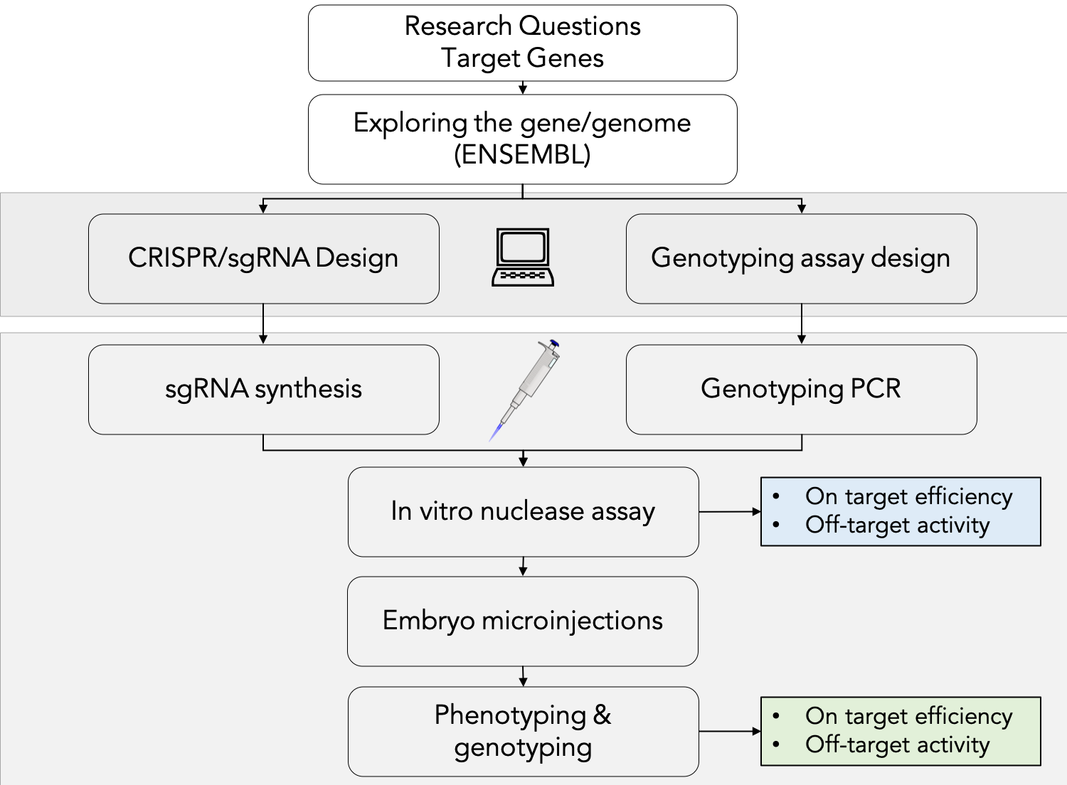

Sequences

 | Gene/guide | Target sequence  (SpyCas9 PAM=NGG) |  | Gene/guide | Target sequence  (SpyCas9 PAM=NGG)
 | cdkn1aEx2-g1 | ACTACTGTACCGCGCGTGTC |  | sox32Ex1-g1 | GGCTTAATGGGCCCGACGCG
 | cdkn1aEx2-g2 | GGCGGCGCTACGGCGCGATC |  | sox32Ex1-g2 | GCGTCTTACTCGAGTTTCCA
 | foxh1Ex2-g1 | CCCGTGATCACCGTAGGAGA |  | sox9bEx1-g1 | GCGGAGTCCTCGGAAAGACT
 | foxh1Ex2-g2 | TGGGCCTTGATTCGTCGCTT |  | sox9bEx1-g2 | GGACAGCGAGACCCCCCGCG
 | jak2aEx15-g1 | GTGCAGGAGTACGTGCGCTT |  | taEx6-g1 | CTGCCCAGTAACGGCCCCAT
 | jak2aEx15-g2 | GGTGGCTAAGCAGCTAGCAT |  | taEx6-g2 | GGGGCCCCATTGAACTGAGG
 | ndr2Ex1-g1 | GAACCAGACGCGCATACCCG |  | tbx5Ex5-g1 | TAAAGCCGTCCGGGCATCGC
 | ndr2Ex1-g2 | TAGAGATGCATCATGTACGT |  | tbx5Ex5-g2 | GGATGGACATAAAGCCGTCC
 | notch1aEx6-g1 | TCCGTGCGAGCAGGCAGCGC |  | tln1Ex29-g1 | GCGTGGCACCACCCAGGACC
 | notch1aEx6-g2 | GGAGGCGACGCGGTCGTGGC |  | tln1Ex29-g2 | GGCCTCGCGTGGCACCACCC
 | rbp1bEx2-g1 | TACGACATGGACTTTGTAGT |  | tln1Ex29-g3 | CGCGTGGCACCACCCAGGAC
 | rbp1bEx2-g2 | CATGGACTTTGTAGTTGGTC |  | tln1Ex29-g4 | CCGGGAAGTTTGGACAAGAC
 | sf3b1Ex7-g1 | TCACTACCTTTGGGACGGCC |  | tln2aEx45-g1 | GCCGTCACTGAGAAGGTACC
 | sf3b1Ex7-g2 | GGTCTCATCCCAACGACTGT |  | tln2aEx45-g2 | CGGCTGCATAGTGCTAGTTC
 | shhaEx1-g1 | GGGCAAGATAACGCGCAATT |  | tln2aEx45-g3 | ACAGACTCGTTCACCAAGAG
 | shhaEx1-g2 | TGTCGCGGAGAAGACCTTAG |  | tln2aEx45-g4 | TCACTGAGAAGGTACCAGGA
 |  |  |  | tpo-g1 | GTATTCTTCGTCCGTGGCAC
 |  |  |  | tpo-g2 | TGGTCGACTGGAAAGTCCGA

SpyCas9  tail oligo | AAAAGCACCGACTCGGTGCCACTTTTTCAAGTTGATAACGGACTAGCCTTATTTTAACTTGCTATTTCTAGCTCTAAAAC

PCR/genotyping primers for amplifying genomic target region
 | Name | Forward primer | Reverse primer | Amplicon size
 | cdkn1aEx2 | acaagccacgcccactgttttc | ACTTCATGCGGGAGTGCAGCAC | 557 bp
 | foxh1Ex2 | ACCTGGAGCCAGCAGTCTGAGG | TGTTGGGGTAGAGCCACGCATC | 604 bp
 | jak2aEx15 | GAGCCAGCTCTCCCATAAAC | CGGGTCACCAGAACATTCC | 394 bp
 | ndr2Ex1 | CTGTCACGGCATGTCAATTTC | CGCCATTGAGCTTTATACACAC | 461 bp
 | notch1aEx6 | tgccttcaactgtacatggtactc | TTGAGTGCTTTGCGGACTACGg | 667 bp
 | rbp1bEx2 | acAATCGCCACTGGAAATTTGC | TGAAGGGAAAACGTTGGGTGGTG | 319 bp
 | sf3b1Ex7 | GGACCCTACGGGACCCATGTTC | TTTCAGCCCAGCCACTGCCATG | 580 bp
 | shhaEx1 | ACCCTGCTAGACAGACCGCTCG | GGGTGAGCAAGGAGGCAAGCAG | 473 bp
 | sox32Ex1 | TCTCGACCGGATGCTCCCTGAC | TGCTGAGGTCAGTGTTCTCCAGG | 299 bp
 | sox9bEx1 | AGCTGATCTGCGCGGTTTTCGG | TGACGTGCGGTTTGCTCTTCCC | 344 bp
 | taEx6 | CCCAGACCACAGCACTGACAACC | GCTGCGGTGGGAGTAATGGCTG | 295 bp
 | tln1Ex29 | TGCACTGAAGGACTGCATGGCC | gctgttagccgaagacgtctgcg | 567 bp
 | tln2aEx45 | AGGGTCGTCTGGCCTCTGCTAC | GTCCAGGTCAGCGATGATGCCG | 493 bp
 | tpo | CAGCATGCCCGGAGAATCAGCC | CACAAAAGGCCACGCTTTGCCC | 401 bp

Protocols

Single guide RNA (sgRNA) synthesis –

Step I: Annealing and extension of oligos for Spy Cas9 system:
Component
Target (gene) specific oligo (100 µM) | 1.5 | µl
Tail Oligo (100 µM) | 1.5 | µl
2x Q5 Master Mix | 3.0 | µl
Total | 6.0 | µl

Denature at 95 C for 3 minutes ramp down to 72 C incubate for 5 minutes ramp down to 25 C

Step II: In vitro transcription (IVT) using AmpliScribe T7-Flash kit from Lucigen
Extension product (from Step II) | 1.375 | μl
AmpliScribe T7-Flash 10X Reaction Buffer | 0.500 | μl
ATP | 0.500 | μl
GTP | 0.500 | μl
CTP | 0.500 | μl
UTP | 0.500 | μl
100 mM DTT | 0.500 | μl
RiboGuard RNase Inhibitor | 0.125 | μl
AmpliScribe T7-Flash Enzyme Solution | 0.500 | μl
Total reaction volume | 5.000 | μl
Incubate at 37 C for 30 minutes to overnight (depending on class schedule)

Step III: DNase I treatment (from T7 Ampliscribe-Flash kit)
In vitro transcribed RNA (from Step III) | 5.00 | µl
DNaseI | 0.25 | µl
Incubate at 37 C for 30 minutes

Step IV: RNA purification
- Add 15 µl of dH2O (to make up IVT reaction volume to 20 µl)
- Add 10 µl (1/2 x transcription reaction volume) 5 M ammonium acetate
- 60 µl (3 x transcription reaction volume) 100% ethanol.
- Mix well, incubate for 20 minutes at -80˚C until frozen (dry ice or liquid nitrogen will also work)
- Centrifuge for 15 minutes at 4˚C, maximum speed.
- Remove the supernatant (by decanting) and add 500 µl 70% ethanol.
- Centrifuge for 5 minutes at 4˚C, maximum speed.
- Remove supernatant (by decanting), dry at room temperature until pellet is dry
- Resuspend in 50 µl RNA storage solution + DTT (1 mM Sodium Citrate pH 6.4 + 20 mM DTT)
- Determine RNA concentration (UV Spectrophotometry)

Step V: 6% Polyacrylamide Gels
# of gels | H₂O | 10x TBE | 40% acrylamide solution (29:1) | 10% APS | TEMED
 | mL | mL | mL | µL | µL
1 | 4.4 | 0.6 | 0.9 | 100 | 5
2 | 8.8 | 1.2 | 1.8 | 200 | 10
3 | 13.2 | 1.8 | 2.7 | 300 | 15
4 | 17.6 | 2.4 | 3.6 | 400 | 20
5 | 22.0 | 3.0 | 4.5 | 500 | 25
6 | 26.4 | 3.6 | 5.4 | 600 | 30
7 | 30.8 | 4.2 | 6.3 | 700 | 35
8 | 35.2 | 4.8 | 7.2 | 800 | 40
9 | 39.6 | 5.4 | 8.1 | 900 | 45
Run in 0.5x TBE buffer at 200 V for 25-30 minutes

Preparation of genomic DNA (embryo lysis)
Collect > 24 hpf embryo into a PCR tube
Add 20 µl embryo lysis solution (50 mM NaOH + 0.2 mM EDTA)
Incubate at 95 C for 10 minutes
Add 2 µl of 1 M Tris-HCl pH 8.0 to the tube (final concentration: 100 mM Tris-HCl)
Store at 4 C for a week or -20 C for long-term storage

Genomic PCR
Genomic DNA (embryo lysis solution) | : | 0.50 | µl
Gene-specific FORWARD primer (10 µM) | : | 0.25 | µl
Gene-specific REVERSE primer (10 µM) | : | 0.25 | µl
2x Q5 Polymerase Master Mix  (or other thermostable DNA polymerase) | : | 5.00 | µl*
dH₂O | : | 4.00 | µl
Total | : | 10.00 | µl
Analyze by agarose or polyacrylamide gel electrophoresis

In vitro sgRNA-Cas9 nuclease assay
CRISPR target/PCR product | : | 1.0 | µl | From genotyping PCR
sgRNA (from Step IV) | : | 0.5 | µl | (250-500 ng/µl)
NEBuffer 3.1 | : | 1.0 | µl
Spy Cas9 (100 ng/µl) | : | 0.5 | µl
dH₂O | : | 7.0 | µl
Total | : | 10.0 | µl

Incubate at 37 C for 30 minutes
Treat with RNase A (10 mg/ml) to degrade sgRNA (0.25 µl) incubate at 37 C for 15 minutes
Treat with Proteinase K (20 mg/ml) to degrade Cas9 protein (0.25 µl) incubate at 37 C for 15 mintues
Analyze reaction products by agarose or polyacrylamide gel electrophoresis

sgRNA-Cas9 ribonucleoprotein (RNP) complex injection into zebrafish embryos
 | Stock conc.  ng/µl | Desired final  Concentration  ng/µl | ng/µl
Cas9 protein | 1000 | 25-50
sgRNA |  | 10-50
RNA storage solution
Total volume |  |  | 10.00
Inject 10-30 nL of injection solution into each 1-2 cell stage embryo

